Project1----tic-tac-tow plan

Part 1 Requirements

Your app must:
- Render a game in the browser
- Switch turns between more than one player
- Design logic for winning & visually display which player won
- Include separate HTML / CSS / JavaScript files
- Stick with KISS (Keep It Simple Stupid) principles
- Use Javascript for DOM manipulation
- Deploy your game online, where the rest of the world can access it
- Use semantic markup for HTML and CSS (adhere to best practices)

Bonus
These are for extra credit! DON'T focus on these until you've hit the core requirements.
- Keep track of multiple game rounds with a win counter
- Allow game customizable options, time limits, board size, game rounds, name & profiles etc
- Allow players to customize their token (X, O, name, picture, avatar etc)
- Get inventive with your styling - research CSS effects, animations to spiff things up
- Research LocalStorage or SessionStorage to persist data locally to allow games to continue after page refresh or loss of internet connectivity
- Use timers to display "waiting..." messages while users are waiting to be matched
- Research web audio API and add sound effects to your game
- Be creative! Bend the rules and give it a twist!

Part 2 Planning Process
1. html layout
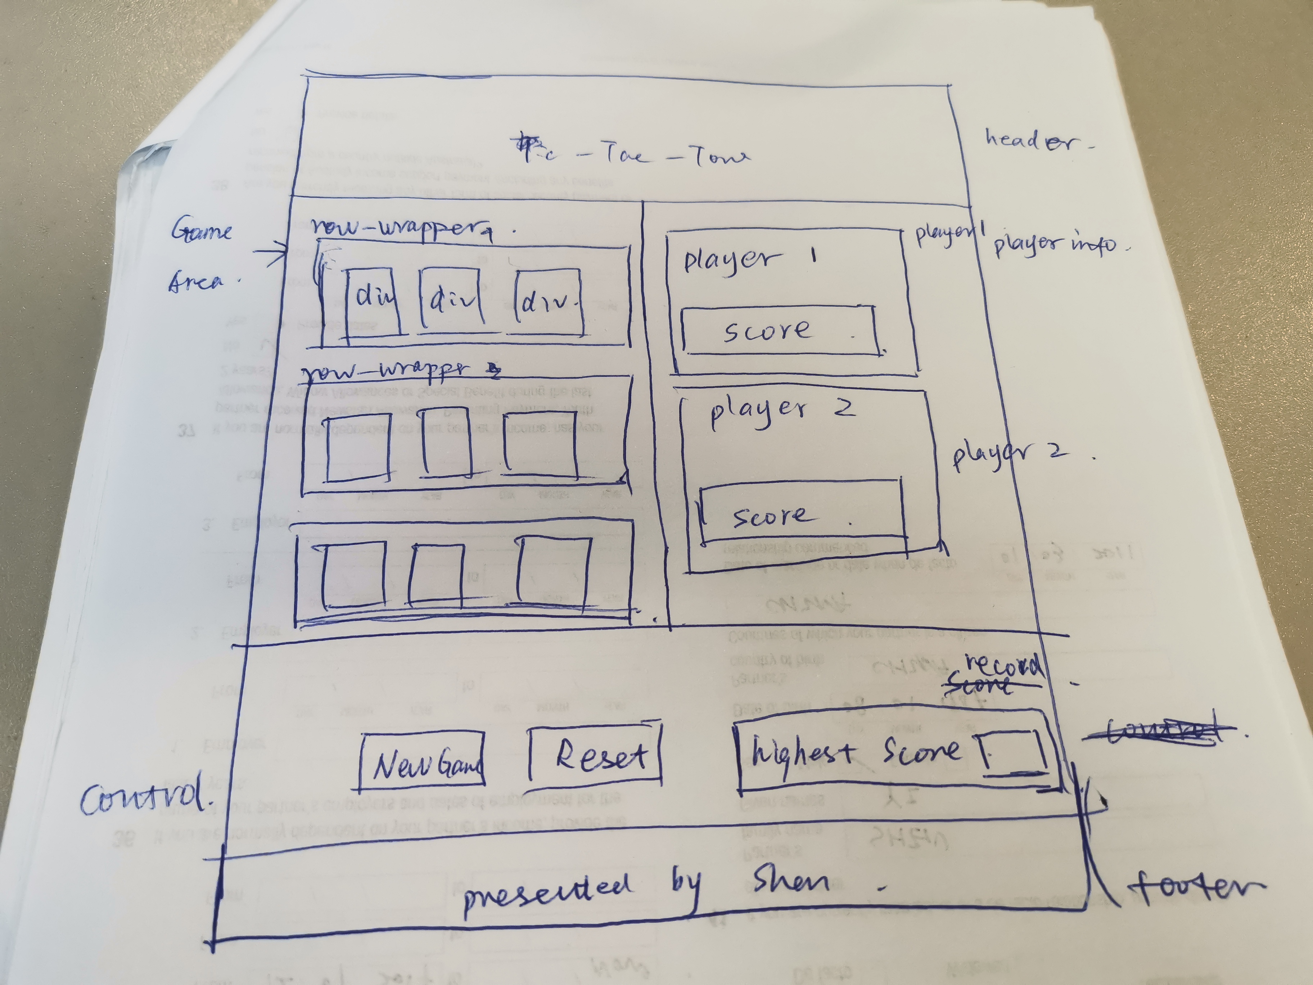
2 css animation https://daneden.github.io/animate.css/
3.JS breakdown
//show the play area
var startGame =function(){
}
var resetGame=function(){
}

// when button clicked ,show the image
var handleClk=function(){

}
// which player in play
var playerInPlay=function(){

}
var checkForWinner=function(){

}
var highlightWinner=function(){

}
var showScore=function(){

}

Part 3 problem encountered

suggestions

- Break the project down into different components (data, presentation, markup, style, DOM manipulation) and brainstorm each component individually. Use whiteboards!
- Use your Development Tools (console.log, inspector, debugger, etc) to debug and solve problems
- Work through the lessons in class & ask questions when you need to! Think about adding relevant code to your game each night, instead of, you know... procrastinating.
- Commit early, commit often. Don’t be afraid to break something because you can always go back in time to a previous version.
- Consult documentation resources (MDN etc.) at home to better understand what you’ll be getting into.
- Don’t be afraid to write code that you know you will have to remove later. Create temporary elements (buttons, links, etc) that trigger events if real data is not available. For example, if you’re trying to figure out how to change some text when the game is over but you haven’t solved the win/lose game logic, you can create a button to simulate that until then.

